**Name – Anirban Bhattacharjee**

**Class Roll Number – 21HCS4116**

**Examination Roll Number - 21015570015**

**Semester – VIth**

**Subject – Artificial Intelligence Practical File**

**Q1. Write a prolog program to calculate the sum of two numbers.**

sum(A, B, C):-

C is A + B.

**OUTPUT & with TRACE COMMAND**

?- sum(4, 5, S).

S = 9.

?- sum(38, 29, X).

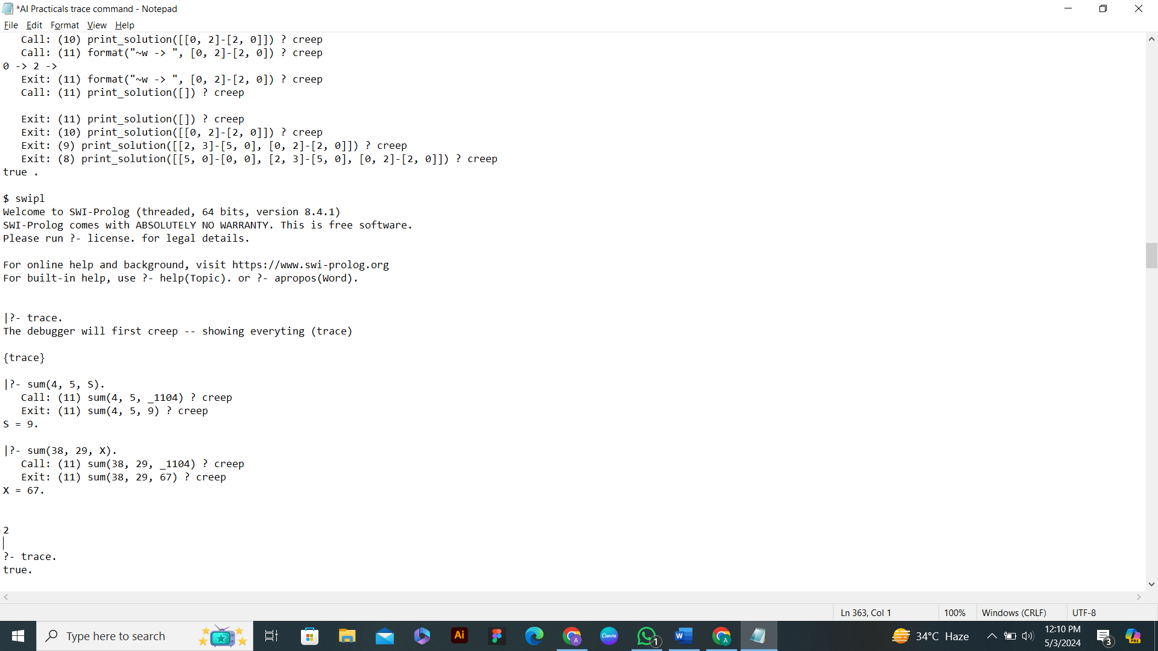X = 67.

**Q2. Write a Prolog program to implement max(X, Y, M) so that M is the maximum of two numbers X and Y.**

max(X, Y, M):- X > Y, M is X, !.

max(X, Y, M):- Y >= X, M is Y.

**OUTPUT & with TRACE COMMAND**

?- max(5, 2, M).

M = 5.

?- max(5, 18, M).

M = 18.

?- max(-37, -19, M).

M = -19.

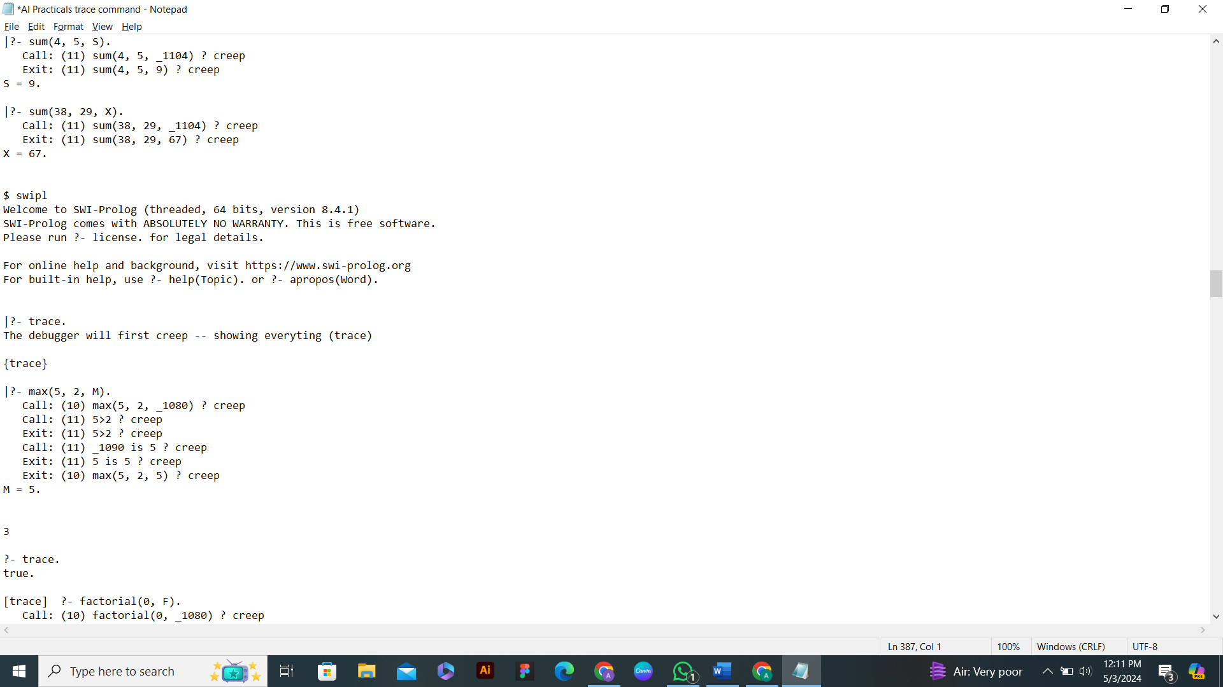

**Q3. Write a program in PROLOG to implement factorial(N, F) where F represents the factorial of a number N.**

factorial(0, 1):- !.

factorial(N, F):-

N > 0,

N1 is N - 1,

factorial(N1, F1),

F is N * F1.

**OUTPUT**

?- factorial(1, F).

F = 1.

?- factorial(5, F).

F = 120.

?- factorial(-5, F).

false.

?- factorial(10, F).

F = 3628800.

**with TRACE COMMAND**

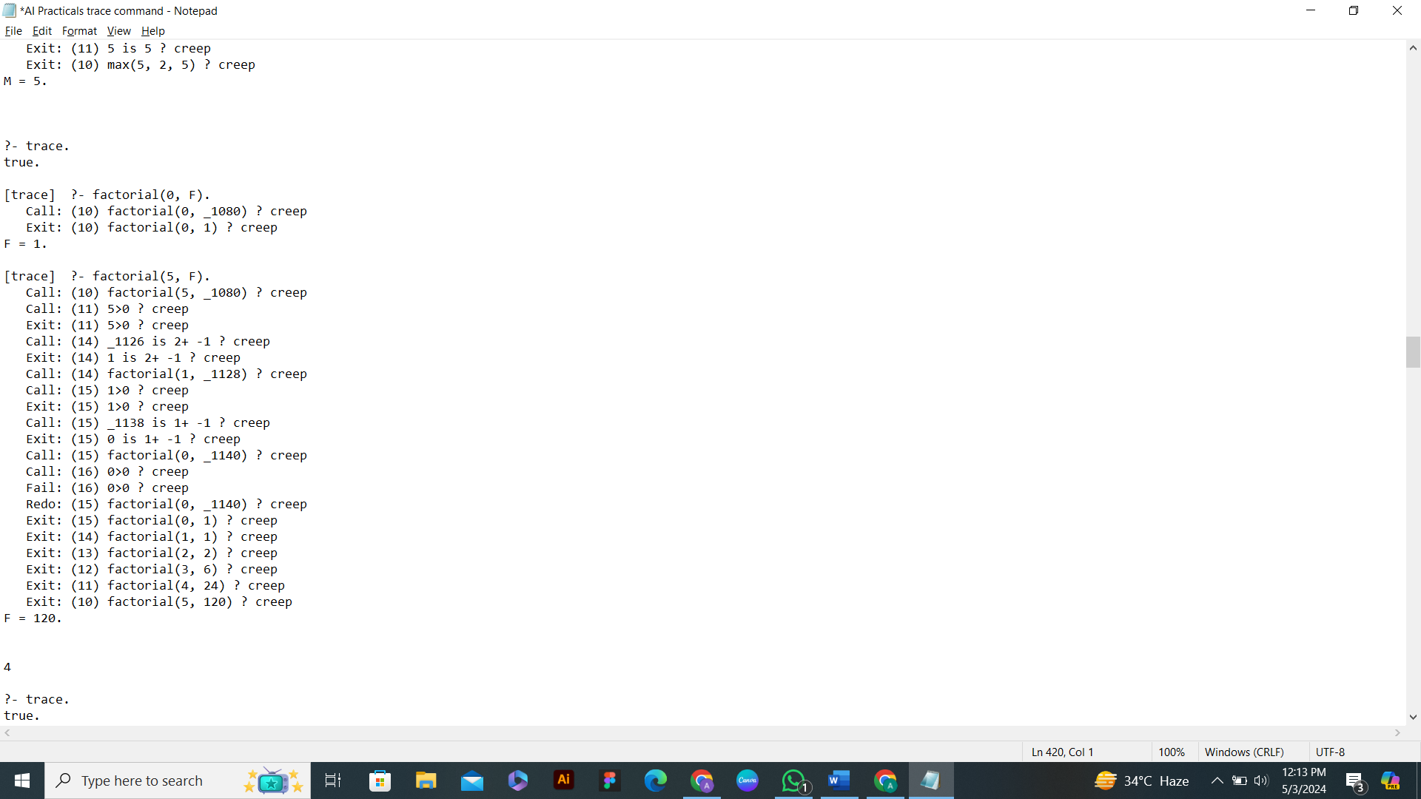

**Q4. Write a program in PROLOG to implement generate fib(N,T) where T represents the Nth term of the fibonacci series.**

fib(1, 0):- !.

fib(2, 1):- !.

fib(N, T):-

N > 2,

N1 is N - 1,

N2 is N1 - 1,

fib(N1, T1),

fib(N2, T2),

T is T1 + T2.

**OUTPUT**

?- fib(1, T).

T = 0.

?- fib(2, T).

T = 1.

?- fib(3, T).

T = 1.

?- fib(4, T).

T = 2.

?- fib(5, T).

T = 3.

?- fib(10, T).

T = 34.

?- fib(-1, T).

false.

**with TRACE COMMAND**

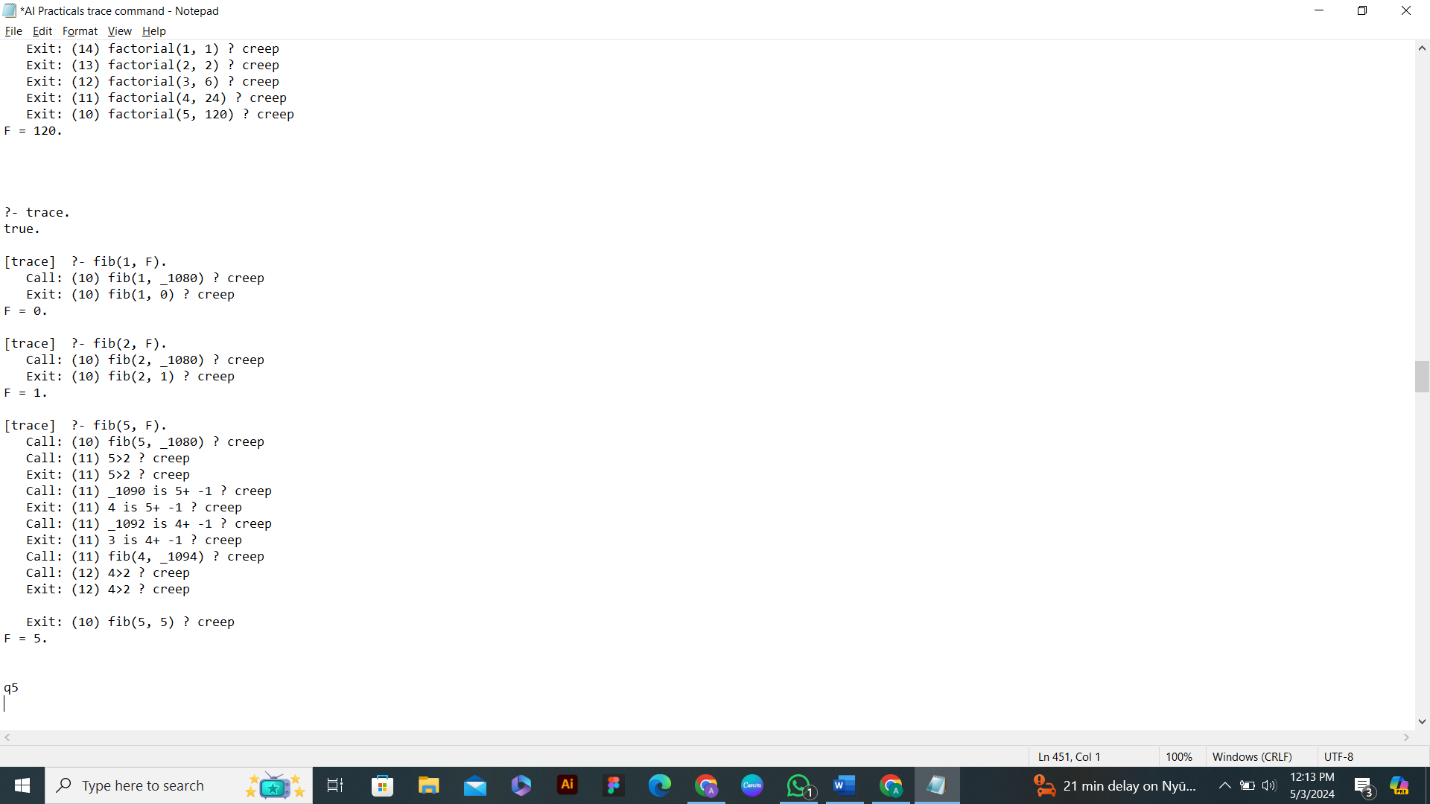

**Q5. Write a Prolog program to implement GCD of two numbers.**

gcd(0, A, A):- !.

gcd(A, 0, A):- !.

gcd(A, B, C):-

B1 is mod(A, B),

gcd(B, B1, C).

**OUTPUT**

?- gcd(15, 25, C).

C = 5.

?- gcd(0, 25, C).

C = 25.

?- gcd(12, 0, C).

C = 12.

?- gcd(12, 13, C).

C = 1.

**with TRACE COMMAND**

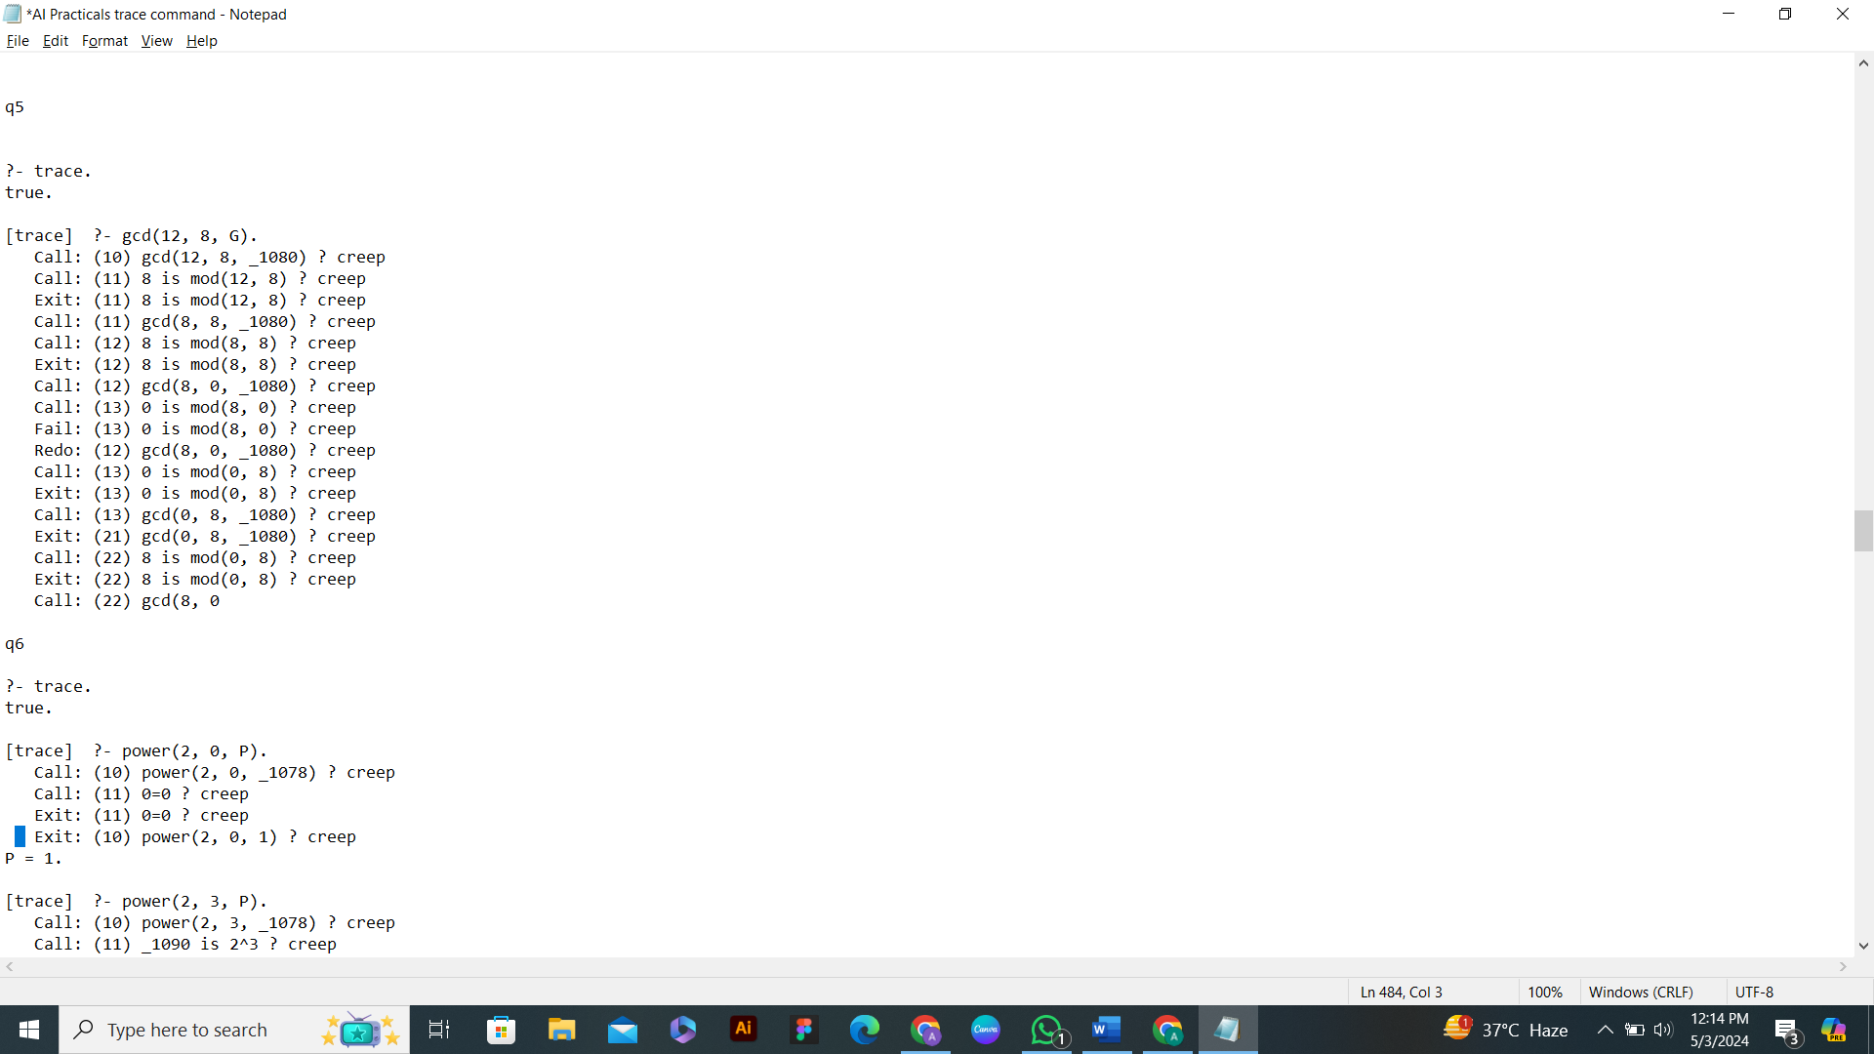

**Q6. Write a Prolog program to implement power(Num,Pow, Ans) : where Num is raised to the power Pow to get Ans.**

power(X, 0, 1):- !.

power(Num, Pow, Ans):-

Ans is Num^Pow.

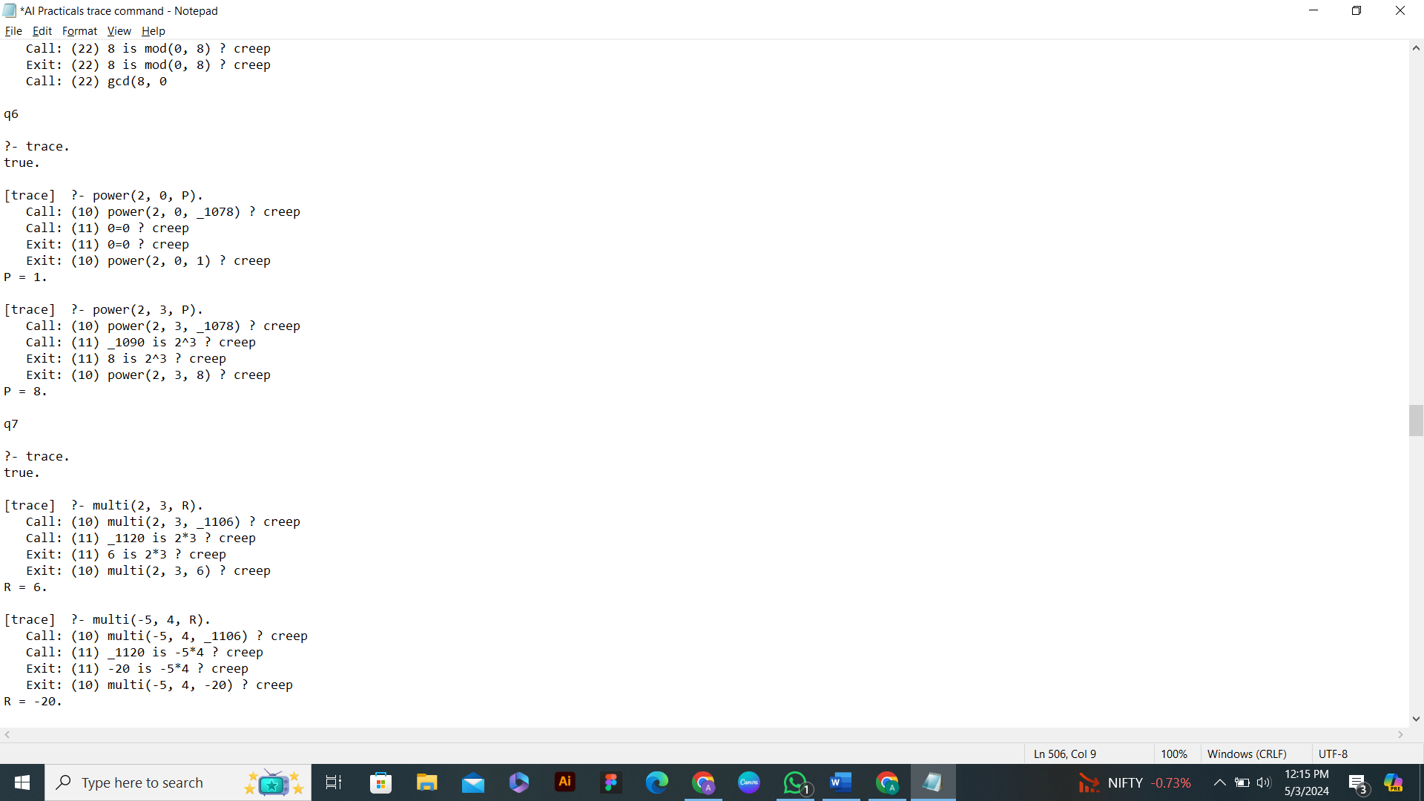

**OUTPUT & with TRACE COMMAND**

?- power(10, 3, Ans).

Ans = 1000.

?- power(5, 6, Ans).

Ans = 15625.

?- power(11, 0, Ans).

Ans = 1.

?- power(11, -3, Ans).

Ans = 0.0007513148009015778.

**Q7. Prolog program to implement multi(N1, N2, R) : where N1 and N2 denotes the numbers to be multiplied and R represents the result.**

multi(N1, N2, R):-

R is N1 * N2.

**OUTPUT**

?- multi(11, 22, R).

R = 242.

?- multi(7, 15, R).

R = 105.

?- multi(7, 0, R).

R = 0.

?- multi(8, -21, R).

R = -168.

**with TRACE COMMAND**

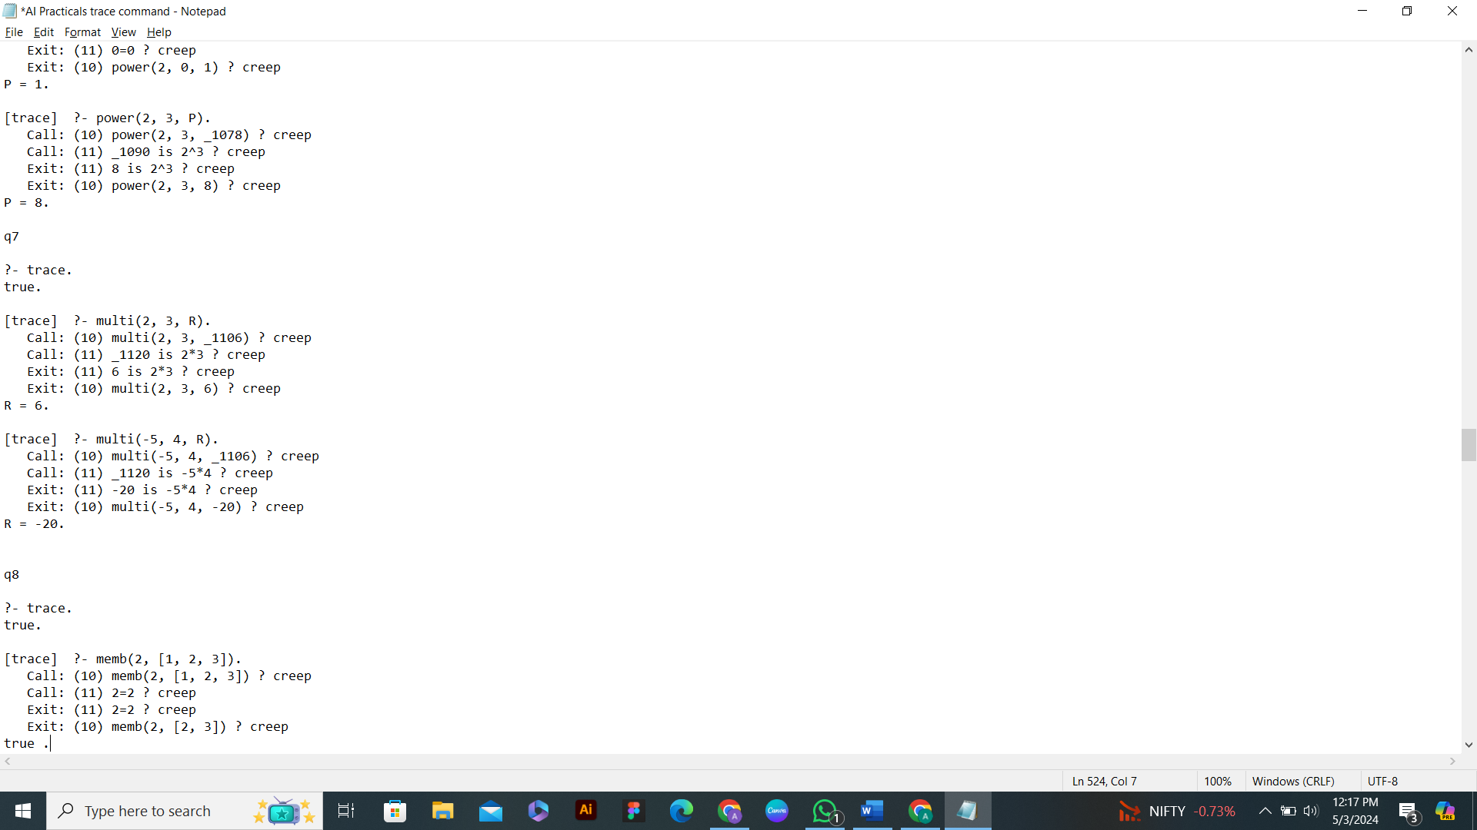

**Q8. Write a Prolog program to implement memb(X, L): to check whether X is a member of L or not.**

memb(X, [X | Tail]).

memb(X, [Head | Tail]):-

memb(X, Tail).

**OUTPUT**

?- memb(b, [a, b, c]).

true .

?- memb(X, [a, b, c]).

X = a ;

X = b ;

X = c ;

false.

?- memb(a, L), memb(b, L), memb(c, L).

L = [a, b, c|_] ;

L = [a, b, _, c|_] ;

L = [a, b, _, _, c|_] ;

...

?- L = [_, _, _],

memb(a, L), memb(b, L), memb(c, L).

L = [a, b, c] ;

L = [a, c, b] ;

L = [b, a, c] ;

L = [c, a, b] ;

L = [b, c, a] ;

L = [c, b, a] ;

false.

?- memb(apple, L).

L = [apple|_] ; % Any list that has “apple” as the head

L = [_, apple|_] ; % First item is anything, second is “apple”

L = [_, _, apple|_] ;

L = [_, _, _, apple|_] ;

**with TRACE COMMAND**

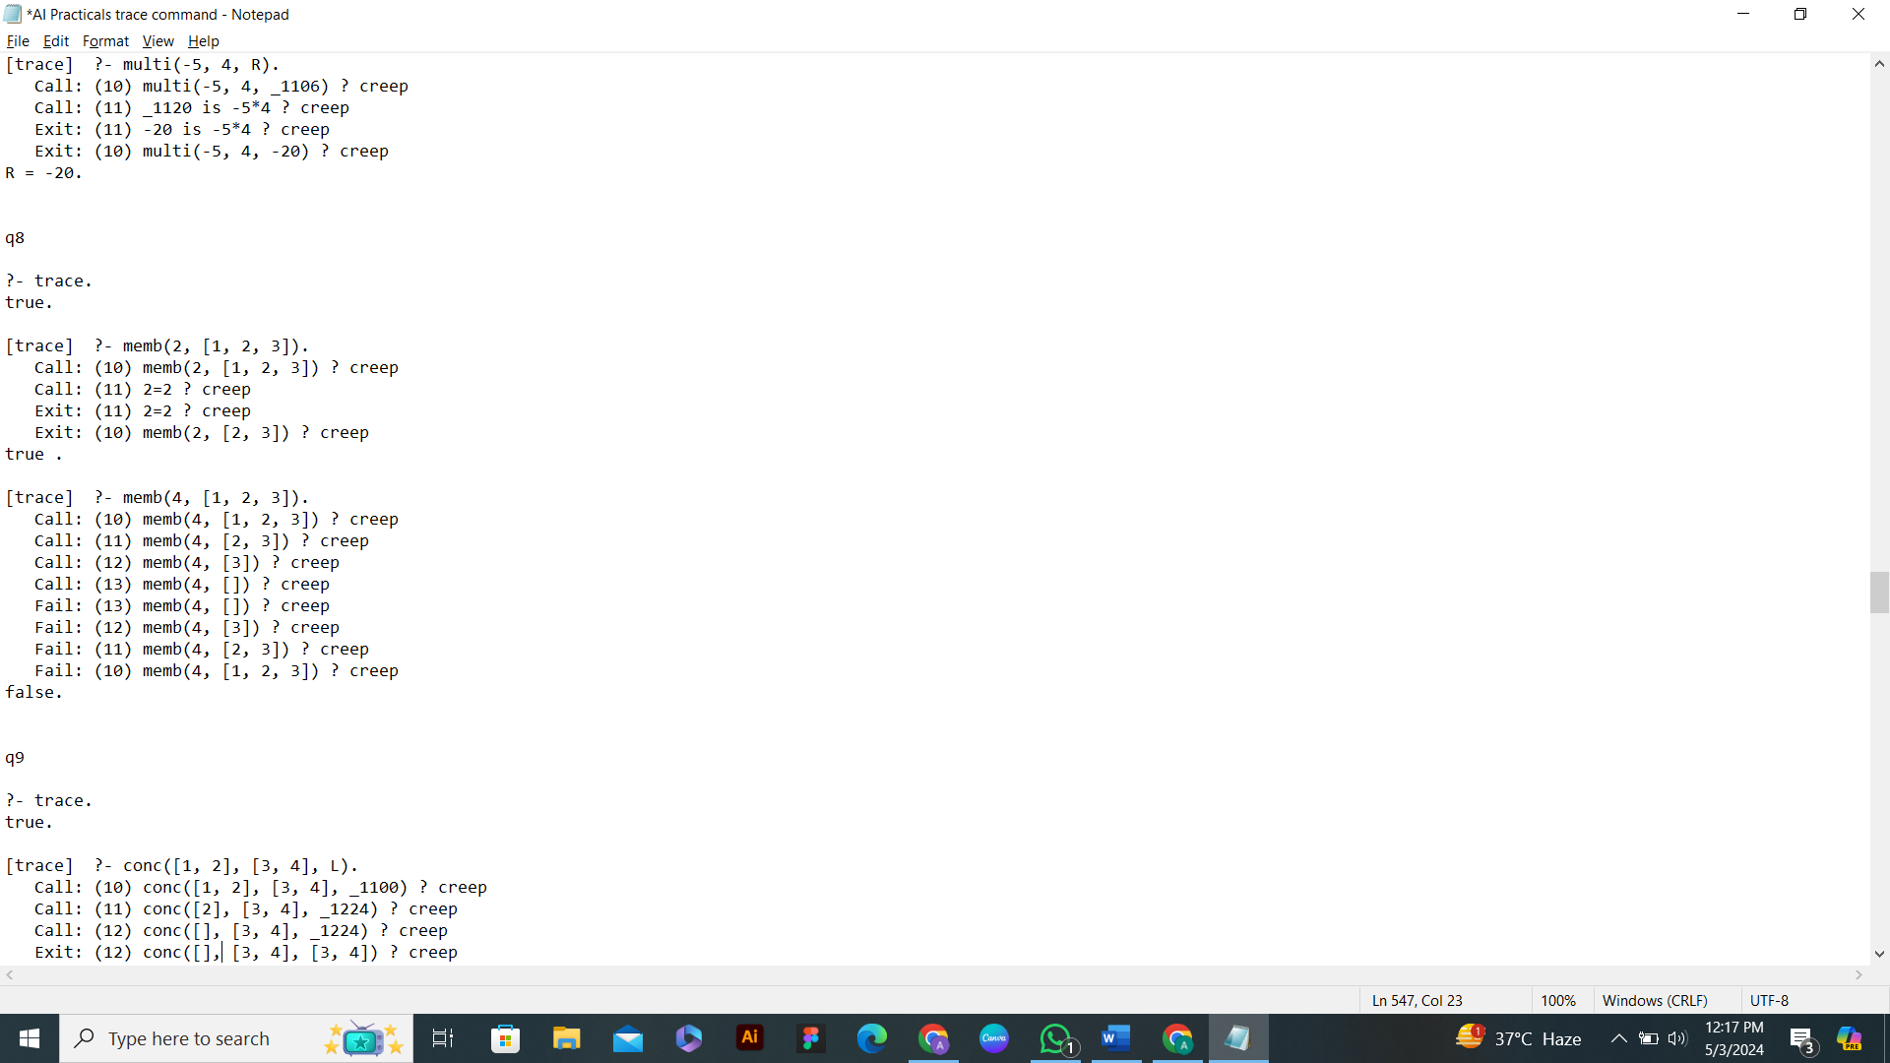

...

**Q9. Write a Prolog program to implement conc (L1, L2, L3) where L2 is the list to be appended with L1 to get the resulted list L3.**

conc([], L, L).

conc([X | L1], L2, [X | L3]):-

conc(L1, L2, L3).

**OUTPUT**

?- conc([a, b, c], [1, 2, 3], L).

L = [a, b, c, 1, 2, 3].

?- conc([a, [b, c], d], [a, [], b], L).

L = [a, [b, c], d, a, [], b].

?- conc(L1, L2, [a, b, c]).

L1 = [],

L2 = [a, b, c] ;

L1 = [a],

L2 = [b, c] ;

L1 = [a, b],

L2 = [c] ;

L1 = [a, b, c],

L2 = [] ;

false.

?- conc(Before, [may | After],

[jan, feb, mar, apr, may, jun, jul, aug, sep, oct, nov, dec]).

Before = [jan, feb, mar, apr],

After = [jun, jul, aug, sep, oct, nov, dec] ;

false.

?- conc(_, [Month1, may, Month2 | _],

[jan, feb, mar, apr, may, jun, jul, aug, sep, oct, nov, dec]).

Month1 = apr,

Month2 = jun ;

false.

?- L1 = [a, b, z, z, c, z, z, z, d, e], % A given list

conc(L2, [z, z, z | _], L1). % L2 is L1 upto 3 z's

L1 = [a, b, z, z, c, z, z, z, d|...],

L2 = [a, b, z, z, c] ;

false.

**with TRACE COMMAND**

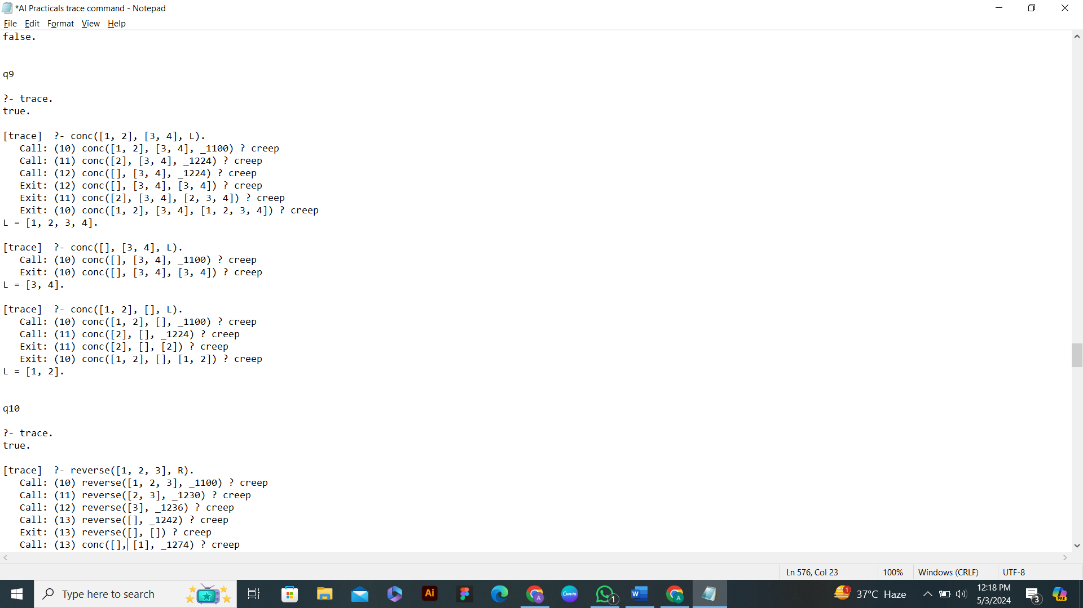

**Q10. Write a Prolog program to implement reverse (L, R) where List L is original and List R is reversed list.**

conc([], L, L).

conc([X|L1], L2, [X|L3]):-

conc(L1, L2, L3).

reverse([], []).

reverse([Head|Tail], R):-

reverse(Tail, L1),

conc(L1, [Head], R).

**OUTPUT**

?- reverse([], R).

R = [].

?- reverse([a, b, c], R).

R = [c, b, a].

?- reverse([a, [b, d], c], R).

R = [c, [b, d], a].

**with TRACE COMMAND**

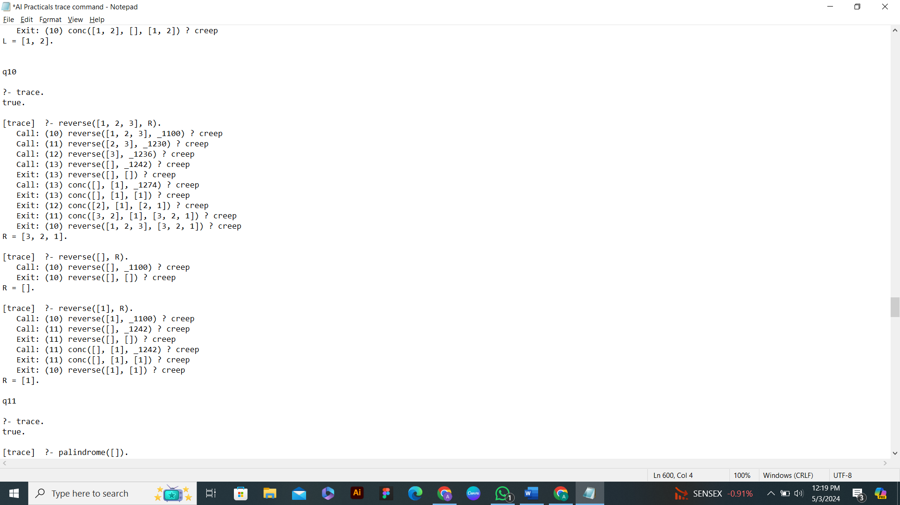

**Q11. Write a program in PROLOG to implement palindrome(L) which checks whether a list L is a palindrome or not.**

conc([], L, L).

conc([X|L1], L2, [X|L3]):-

conc(L1, L2, L3).

palindrome([]):- !.

palindrome([_]):- !.

palindrome(L):-

conc([Head|Tail], [Head], L),

palindrome(Tail), !.

**OUTPUT**

?- palindrome([]).

true.

?- palindrome([a]).

true.

?- palindrome([a, b, a]).

true.

?- palindrome([a, b, b]).

False

**with TRACE COMMAND**

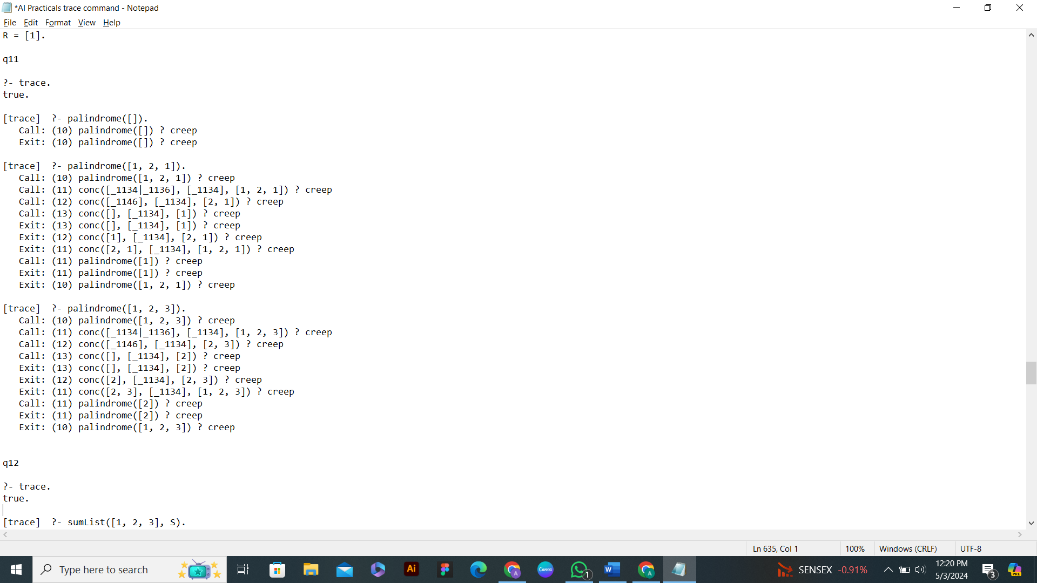

**Q12. Write a Prolog program to implement sumlist(L, S) so that S is the sum of a given list L.**

sumList([], 0).

sumList([Head|Tail], S):-

sumList(Tail, X),

S is Head + X.

**OUTPUT**

?- sumList([1], S).

S = 1.

?- sumList([1, 2, 3], S).

S = 6.

?- sumList([], S).

S = 0.

**with TRACE COMMAND**

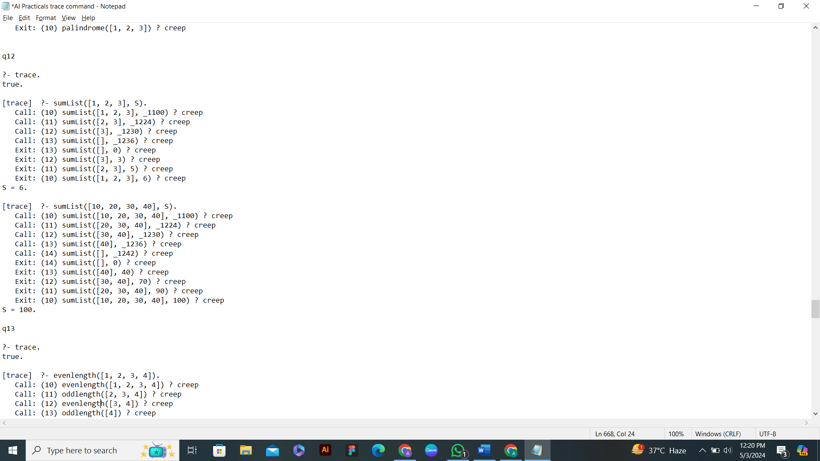

**Q13. Write a Prolog program to implement two predicates evenlength(List) and oddlength(List) so that they are true if their argument is a list of even or odd length respectively.**

evenlength([]):- !.

evenlength([_|T]):- oddlength(T).

oddlength([_]):- !.

oddlength([_|T]):- evenlength(T).

**OUTPUT**

?- evenlength([]).

true.

?- evenlength([1]).

false.

?- oddlength([1]).

true.

?- oddlength([]).

false.

?- oddlength([1, 2, 3, 4]).

false.

?- evenlength([1, 2, 3, 4]).

true.

**with TRACE COMMAND**

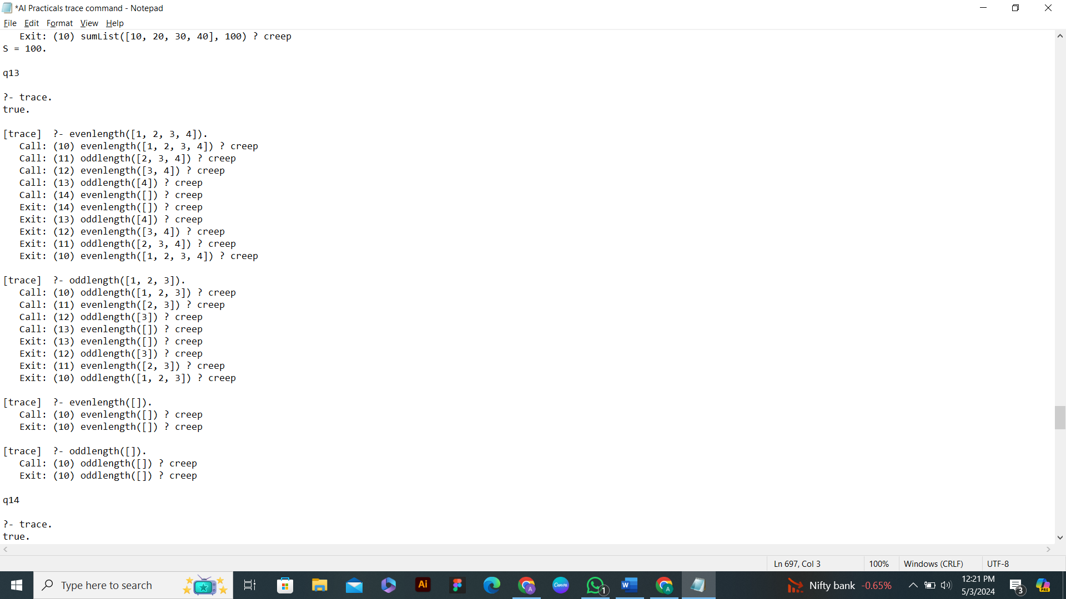

**Q14. Write a Prolog program to implement nth_element(N, L, X) where N is the desired position, L is a list and X represents the Nth element of L.**

nth_element(1, [H|_], H):- !.

nth_element(N, [_|T], X):-

N > 0,

N1 is N - 1,

nth_element(N1, T, X).

**OUTPUT**

?- nth_element(1, [a, b, c, d, e, f], X).

X = a.

61 ?- nth_element(2, [a, b, c, d, e, f], X).

X = b.

62 ?- nth_element(3, [a, b, c, d, e, f], X).

X = c.

63 ?- nth_element(4, [a, b, c, d, e, f], X).

X = d.

**with TRACE COMMAND**

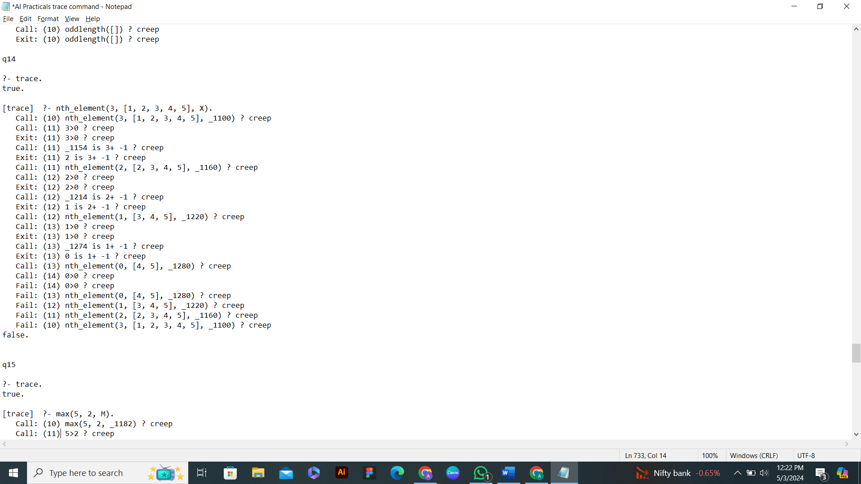

**Q15. Write a Prolog program to implement maxlist(L, M) so that M is the maximum number in the list.**

max(X, Y, M):- X > Y, M is X, !.

max(X, Y, M):- Y >= X, M is Y.

maxlist([H], H):- !.

maxlist([H|T], M):-

maxlist(T, M1),

max(H, M1, M).

**OUTPUT**

?- maxlist([1, 2, 3, 4, 5], M).

M = 5.

?- maxlist([1], M).

M = 1.

?- maxlist([], M).

false.

?- maxlist([62, 37, 13, 37, 23, 82, 28], M).

M = 82

**with TRACE COMMAND**

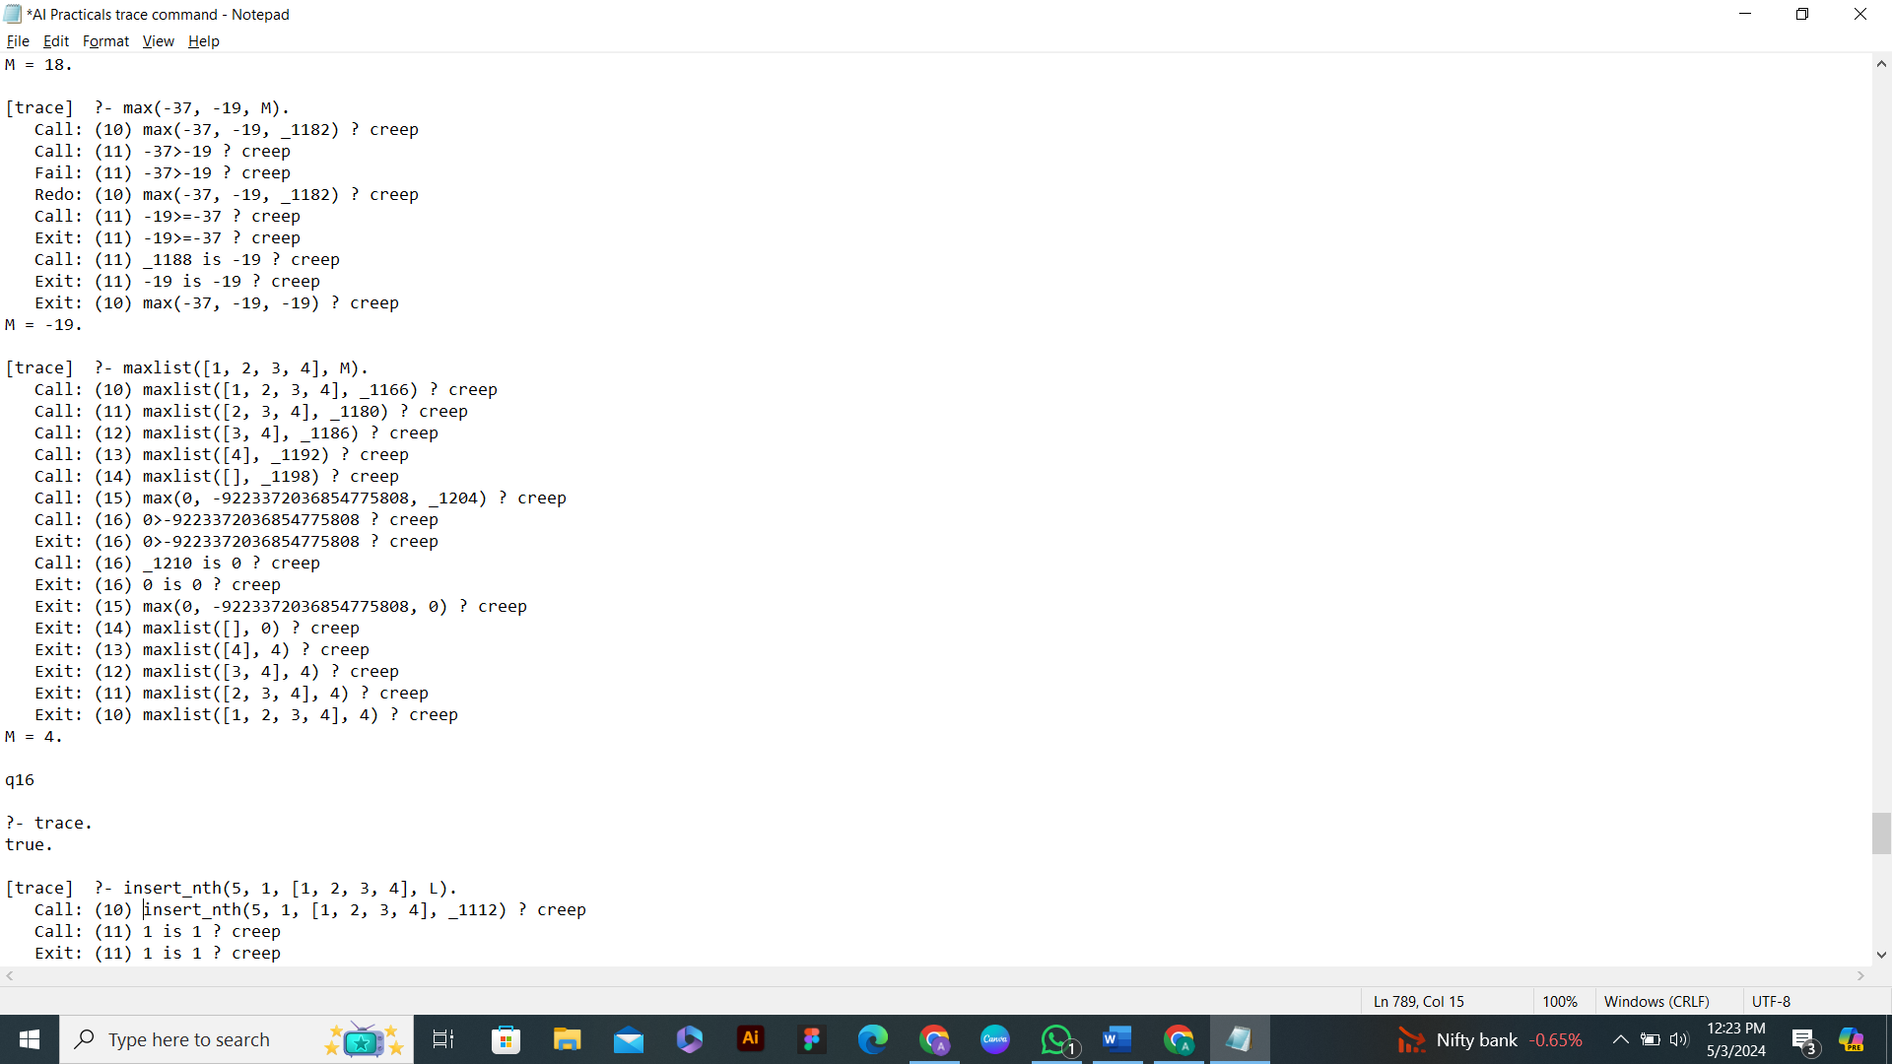

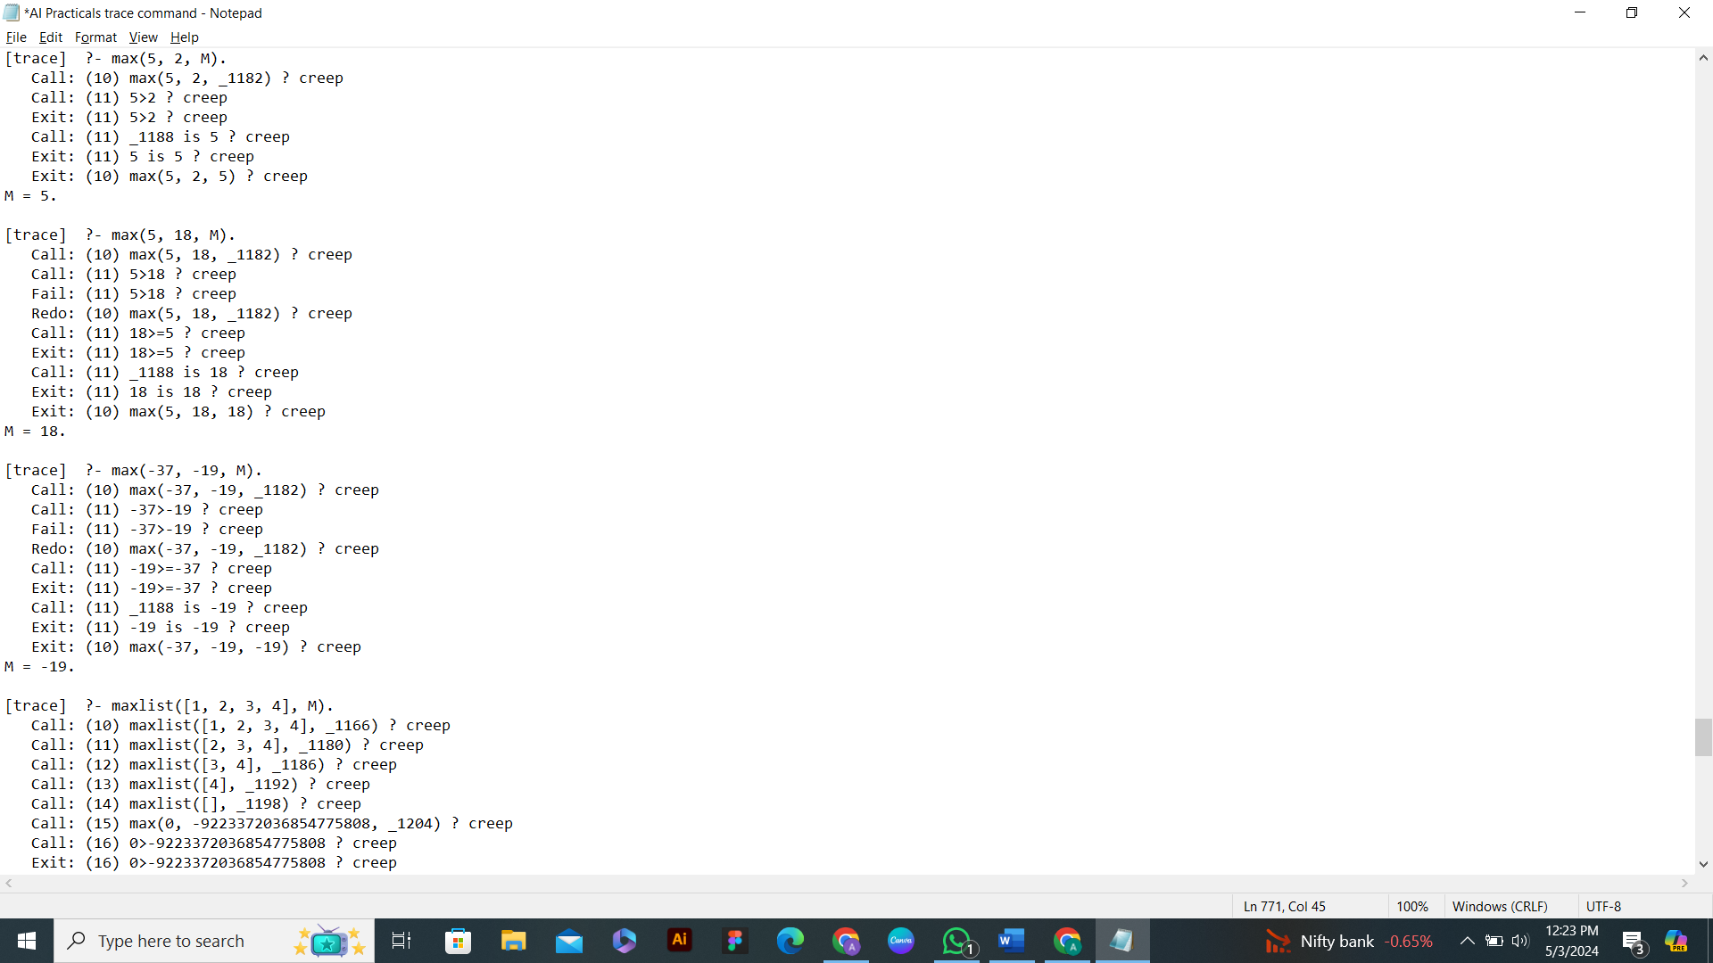

**Q16. Write a prolog program to implement insert_nth(I, N, L, R) that inserts an item I into Nth position of list L to generate a list R.**

insert_nth(I, 1, L, [I|L]):- !.

insert_nth(I, N, [H|T], [H|T1]):-

N1 is N - 1,

insert_nth(I, N1, T, T1).

**OUTPUT**

?- insert_nth(2, 2, [1,3,4,5], R).

R = [1, 2, 3, 4, 5].

?- insert_nth(20, 1, [1,3,4,5], R).

R = [20, 1, 3, 4, 5].

?- insert_nth(20, 5, [23, 535, 55, 34, 56, 778, 67, 97], R).

R = [23, 535, 55, 34, 20, 56, 778, 67, 97].

?- insert_nth(25, 15, [23, 535, 55, 34, 56, 778, 67, 97], R).

false.

**with TRACE COMMAND**

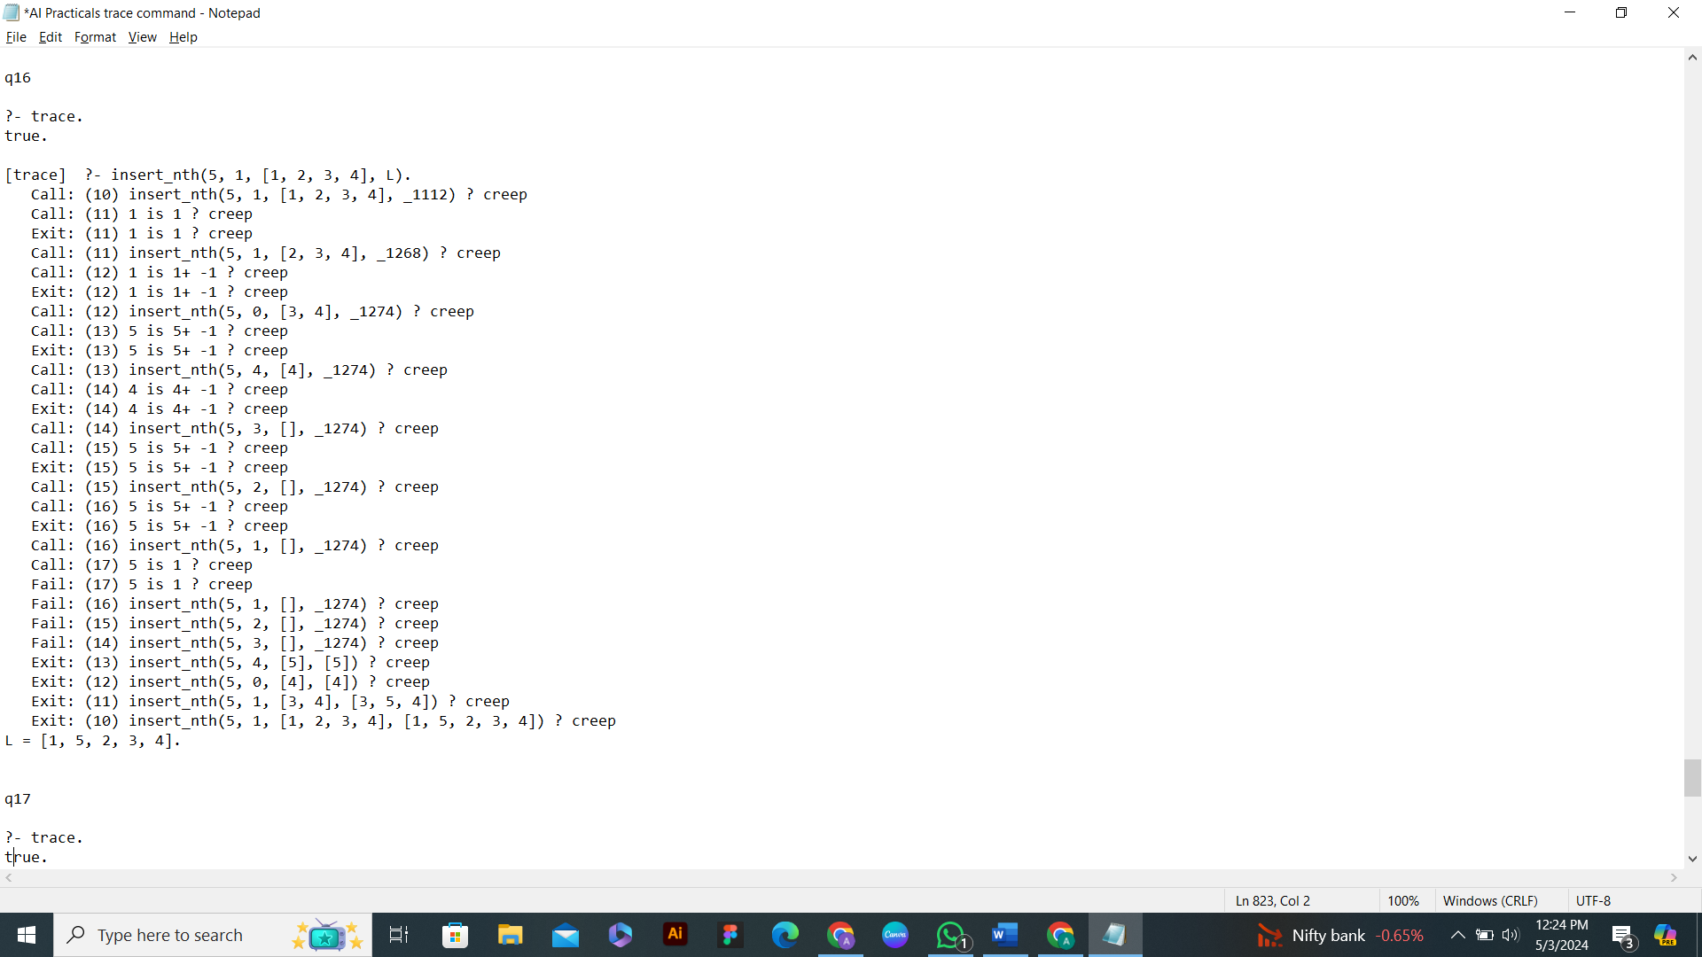

**Q17. Write a Prolog program to implement delete_nth(N, L, R) that removes the element on Nth position from a list L to generate a list R.**

delete_nth(1, [H|T], T):- !.

delete_nth(N, [H|T], [H|T1]):-

N1 is N - 1,

delete_nth(N1, T, T1).

**OUTPUT**

?- delete_nth(2, [1, 2, 3, 4, 5], R).

R = [1, 3, 4, 5].

?- delete_nth(1, [20, 1, 3, 4, 5], R).

R = [1, 3, 4, 5].

?- delete_nth(5, [23, 535, 55, 34, 20, 56, 778, 67, 97], R).

R = [23, 535, 55, 34, 56, 778, 67, 97].

?- delete_nth(15, [23, 535, 55, 34, 20, 56, 778, 67, 97], R).

false.

**with TRACE COMMAND**

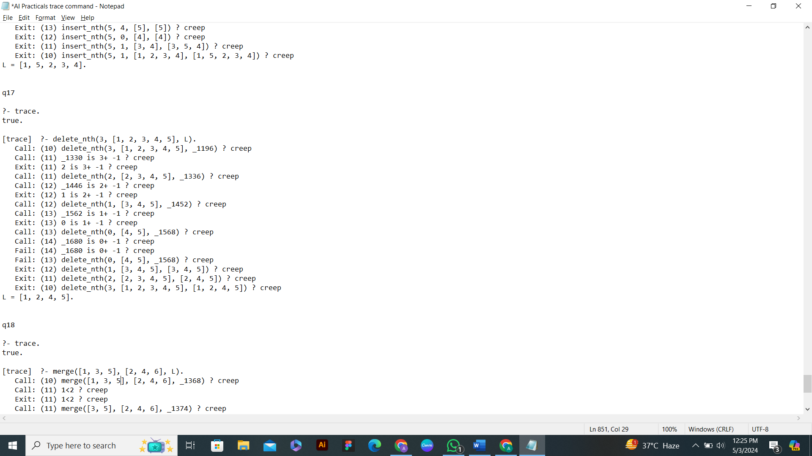

**Q18. Write a program in PROLOG to implement merge(L1, L2, L3) where L1 is first ordered list and L2 is second ordered list and L3 represents the merged list.**

merge([H1|T1], [H2|T2], [H1|T]):-

H1 < H2, !,

merge(T1, [H2|T2], T).

merge([H1|T1], [H2|T2], [H2|T]):-

merge([H1|T1], T2, T), !.

merge(L1, [], L1):- !.

merge([], L2, L2).

**OUTPUT**

?- merge([1, 3, 5, 7], [2, 4, 6, 8], L).

L = [1, 2, 3, 4, 5, 6, 7, 8].

?- merge([1, 3, 5, 6, 8], [2, 4, 6, 7], L).

L = [1, 2, 3, 4, 5, 6, 6, 7, 8].

**with TRACE COMMAND**

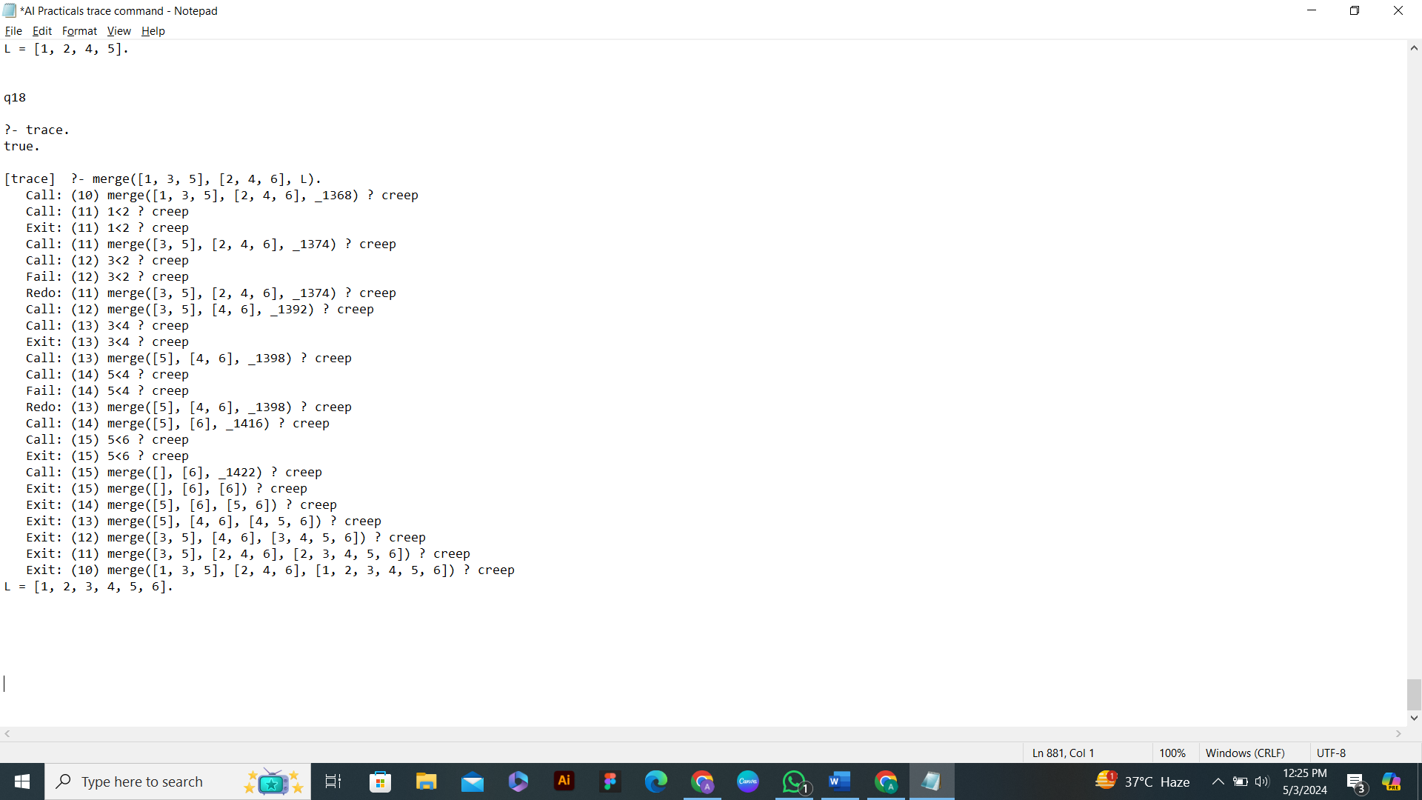

**COMPLETE**

**THANK YOU**

**ANIRBAN BHATTACHARJEE**

**BATCH 2021-2024**